

**G.H. Raisoni College of Engineering & Management , Pune**

(An Autonomous Institute Affiliated to SPPU)

**Department: S.Y. Computer Engineering**

**Subject**: **(BITL202-Object Oriented Programming)**

Topic:-“TOURISM MANAGEMENT SYSTEM”

Submitted To:

Prof. Diksha Bhoyar

Submitted by:

Group No. :-A1

**Amit Tiwari (SCOA01)**

**Vidhyasagar Babalsure (SCOA02)**

**Abhijit Kale (SCOA18)**

Index

1. **Introduction**

1.1 Objective

1.2 Scope

1. **Abstract**

**3. Requirements Specification**

3.1 Hardware Requirements

3.2 Software Requirements

**4. Flowchart**

**5. Class Diagram**

**6. Source code**

**7. Output screen shots**

**8. Advantages**

**9. References**

**1.Introduction**

The Tours and Travel Management System is a web based application. The main purpose of “Tours and travels management system ” is to provide a convenient way for a customer to book hotels, flight, train and bus for tour purposes. The objective of this project is to develop a system that automates the processes and activities of a travel agency. In this project, We will make an easier task of searching places and for booking train, flight or bus.In the present system a customer has to approach various agencies to find details of places and to book tickets. This often requires a lot of time and effort. We provide approach skills to critically examine how a tourist visits and its ability to operate in an appropriate way when dealing with the consequences of tourism, locally, regionally, and nationally including visitor security and ecological influences. It is tedious for a customer to plan a particular journey and have it executed properly. The project ‘Tours and Travels Management System’ is developed to replace the currently existing system, which helps in keeping records of the customer details of destination as well as payment received.

**1.1 Objective**

➢ This application is develop to provide best travelling services to the customers and travel agents.

➢ We have developed tours and travel management system to provide a search platform where a tourist can find their tour places according to their choices.

➢ This system also helps to promote responsible and interesting tourism so that people can enjoy their holidays at their favourable places.

➢ This system also helps to develop tourism with different cultures so that they enrich the tourism experience and build pride.

➢ We develop this system to create and promote forms of tourism that provide healthy interaction opportunities for tourists and locals and increase better understanding of different cultures, customs, lifestyles, traditional knowledge and believes.

➢ This system also provide a better way to connect with various events.

This system also gives tours related information like which places are tourist attractions, cities, and provinces. Tourist can also get the Map and navigation system and temperature and weather information.

**1.2 Scope**

Online tour and travelling booking system has a wide range of scope in the coming era. This technology(system) has started to make a strong feet in online business and it is continue to be developing in next few decades. Implementing this system globally will reduce the risk of fraud with 100% transparency without involvement of any third party tourism agent. ‘Tours and Travels Management System’ is developed to replace the currently existing system, which helps in keeping records of the customer details of destination as well as payment received. Customer will have complete detail of the location as everything is made available before confirming the booking online. This system also gives tours related information including which spots are tourist attractions, cities, and provinces.Further scope of travel and tourism management system includes the GPS and weather tracing information that is readily made available depending on weather prediction which inturns reduces the rate of death due to natural disaster. So implementation of this system is going to be life saver as it is promising technology of

the 21 st century.

**2. Abstract**

Online Tour and Traveling Booking is a system that gives you facility of booking any type of Tours and Travels. This system is made so that Customer will not have to Come to us to Book his\her Tours. The project ‘Tours and Travels Management System’ is developed to replace the currently existing system, which helps in keeping records of the customer, details of destination as well as payment received. In the present era where “time” proves to be the most important asset for an individual by replacing the current register system to fully computerize, it not only saves the precious asset that is time, but also accuracy, reliability and uniformity can be maintained. This project is useful for the manager of the company as it helps them to search the data faster than existing system, to get customer record easily and report of the customer, payment, etc are generated as per requirement.

**3. Requirement Specification**

It specifies the hardware requirements like memory restrictions, cache size, the processor, RAM size etc... Those are required for the software to run.

**3.1 Hardware requirements**

▪ Minimum Hardware Requirements

▪ Processor: Intel Pentium III / Intel core to duo (any singe core

▪ with clock frequency of 1.00 GHz )

▪ Hard disk drive :40 GB

▪ RAM :500 MB

▪ Cache: 512 kb

▪ Preferred Hardware Requirements

▪ Processor: Pentium IV or advanced

▪ Hard disk drive: 80 GB

▪ RAM: 1 GB

▪ Cache: 1 MB

**3.2 Software requirement**

▪ Operating System: Windows XP and above, all Linux Operating system

▪ Dos Emulator is mandatory.

▪ Compiler required: Turbo C++, GNU Compiler (Code block) and Code Warrior etc.

Code block : It is a free open source cross platform IDE the support multiple compiler GNU GCC, Clang and Visual C++. It is developed in C++ using wxWidgets as the GUI

toolkit.

**4.Flowchart**

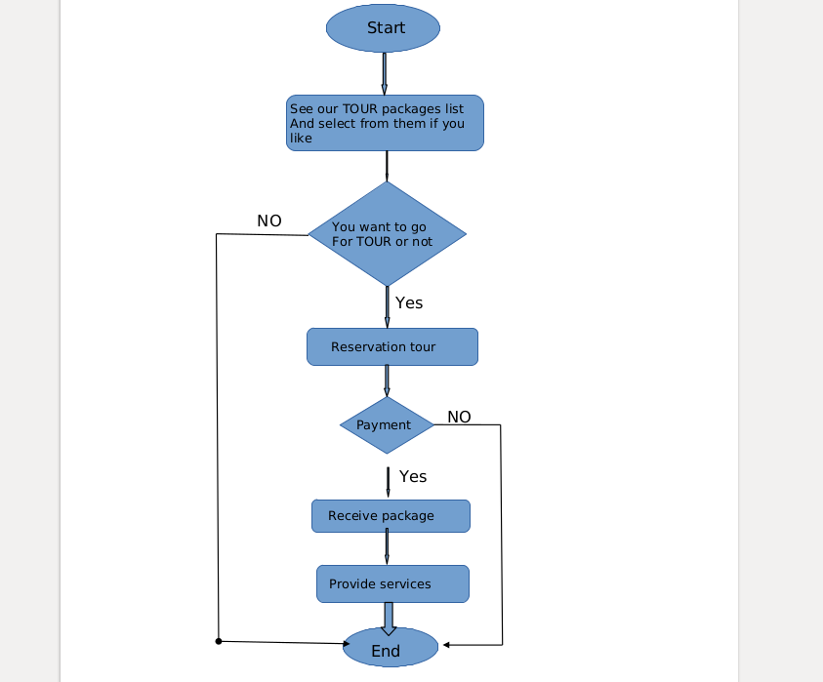

**Source Code:**

#include<fstream>

//#include<conio.h>

#include<cstring>

#include<iomanip>

#include<iostream>

#include <cstdlib>

using namespace std;

class tour1

{

public:

int no_of_days;

char add[50],mobile_no[10];

string date;

char name[20];

void customer_data()

{

cout<<"Enter your name: ";

cin.ignore();

cin.getline(name ,20);

cout<<"Enter your address: ";

cin.ignore();

cin.getline(add ,50);

cout<<"Enter your mobile number: ";

cin.ignore();

cin.getline(mobile_no ,10);

cout<<"On which date you want to go to tour ?";

cin>>date;

cout<<"How many days you wany to stay there ?";

cin>>no_of_days;

cout<<"\n\nThank You...";

getchar();

system("cls");

}

void show_bill()

{

cout<<"Name of CUSTOMER :"<<name<<"\n"<<endl;

cout<<"address :"<<add<<"\n"<<endl;

cout<<"mobile number :"<<mobile_no<<"\n"<<endl;

cout<<"date on which you are going to tour :"<<date<<"\n"<<endl;

cout<<"Number of days you stay there :"<<no_of_days<<"\n"<<endl;

getchar();

}

char* get_cuctomer_name(){

return name;

}

char* get_add(){

return add;

}

char* get_mobileno(){

return mobile_no;

}

};

class tour : public tour1

{

public:

int tour_number;

char city_name[50];

float tour_price,tax,tour_discount;

void create_tour()

{

cout<<setw(31)<<endl<<"Enter The tour Number: ";

cin>>tour_number;

cout<<setw(29)<<endl<<"Enter The city Name: ";

cin.ignore();

cin.getline(city_name ,50);

cout<<setw(37)<<endl<<"Enter The Price of The tour: ";

cin>>tour_price;

cout<<setw(32)<<endl<<"Enter The Discount (%): ";

cin>>tour_discount;

}

void show_tour()

{

cout<<"\t"<<tour_number<<"\t\t"<<city_name<<"\t\t"<<tour_price<<"\t\t"<<setprecision(4)<<tour_discount;

}

int gettour()

{

return tour_number;

}

float gettour_price()

{

return tour_price;

}

char* getName()

{

return city_name;

}

float getDiscount()

{

return tour_discount;

}

};

fstream fp;

tour t;

float amt,damt,total=0;

int order_arr[50],quan[50],c=0;

void save_tour()

{

fp.open("tour.txt",ios::out|ios::app);

//t.Country();

t.create_tour();

fp.write((char*)&t,sizeof(tour));

fp.close();

cout<<endl<<endl<<"The tour Has Been Successfully Created...";

getchar();

}

void show_all_tour()

{

system("cls");

cout<<endl<<"\t\tRECORDS."<<endl;

cout<<"\tTourNumber\tTourName\tTourPrice\tDiscount"<<endl;

fp.open("tour.txt",ios::in);

while(fp.read((char*)&t,sizeof(tour)))

{

t.show_tour();

cout<<"\n";

getchar();

}

fp.close();

}

void display_record(int num)

{

bool found=false;

fp.open("tour.txt",ios::in);

while(fp.read((char*)&t,sizeof(tour)))

{

if(t.gettour()==num)

{

system("cls");

t.show_tour();

found=true;

}

}

fp.close();

if(found == true)

cout<<"\n\nNo record found";

getchar();

}

void edit_tour()

{

int num;

bool found=false;

system("cls");

cout<<endl<<endl<<"\tPlease Enter The tour : ";

cin>>num;

fp.open("tour.txt",ios::in|ios::out);

while(fp.read((char*)&t,sizeof(tour)) && found==false)

{

if(t.gettour()==num)

{

t.show_tour();

cout<<"\nPlease Enter The New Details of tour: "<<endl;

t.create_tour();

int pos=1*sizeof(t);

fp.seekp(pos,ios::cur);

fp.write((char*)&t,sizeof(tour));

cout<<endl<<endl<<"\t Record Successfully Updated...";

found=true;

}

}

fp.close();

if(found==false)

cout<<endl<<endl<<"Record Not Found...";

getchar();

}

void delete_tour()

{

int num;

system("cls");

cout<<endl<<endl<<"Please Enter The tour #: ";

cin>>num;

fp.open("tour.txt",ios::in|ios::out);

fstream fp2;

fp2.open("Temp.txt",ios::out);

fp.seekg(0,ios::beg);

while(fp.read((char*)&t,sizeof(tour)))

{

if(t.gettour()!=num)

{

fp2.write((char*)&t,sizeof(tour));

}

}

fp2.close();

fp.close();

remove("tour.txt");

rename("Temp.txt","tour.txt");

cout<<endl<<endl<<"\tRecord Deleted...";

getchar();

}

void tour_menu()

{

system("cls");

fp.open("tour.txt",ios::in);

cout<<endl<<endl<<"********* TOUR MENU **********\n\n";

cout<<"T.NO\t\tNAME\t\tPRICE\t\tDISCOUNT"<<endl;

while(fp.read((char*)&t,sizeof(tour)))

{

cout<<t.gettour()<<"\t\t"<<t.getName()<<"\t\t"<<t.gettour_price()<<"\t\t"<<t.getDiscount()<<endl;

}

fp.close();

}

void place_tour()

{

char ch='Y';

tour_menu();

cout<<"\nPLEASE SELECT YOUR TOUR FROM THE ABOVE MENU.....";

do{

cout<<"\n\nEnter the tour number: ";

cin>>order_arr[c];

cout<<"\nEnter no of people want to go: ";

cin>>quan[c];

c++;

cout<<"\nDo You Want To Order Another tour ? (y/n): ";

cin>>ch;

}while(ch=='y' ||ch=='Y');

getchar();

}

fstream fp1;

void bill()

{

cout<<"\n\n********************************FINAL BILL************************\n";

//fp1.open("record.txt",ios::in);

//while(fp1.read((char*)&t,sizeof(tour)))

//{

t.show_bill();

getchar();

//}

//fp1.close();

cout<<"\nPr No.\tPr Name\tQuantity \tPrice \tAmount \tAmount after discount\n";

for(int x=0;x<=c;x++)

{

fp.open("tour.txt",ios::in|ios::app);

fp.read((char*)&t,sizeof(tour));

while(!fp.eof())

{

if(t.gettour()==order_arr[x])

{

amt=t.gettour_price()*quan[x];

damt=amt-(amt*t.getDiscount()/100);

cout<<"\n"<<order_arr[x]<<"\t"<<t.getName()<<"\t"<<quan[x]<<"\t\t"<<t.gettour_price()<<"\t"<<amt<<"\t\t"<<damt;

total+=damt;

}

fp.read((char*)&t,sizeof(tour));

}

fp.close();

}

cout<<"\n\n\t\t\t\t\tTOTAL = "<<total;

}

void booking()

{

fp1.open("record.txt",ios::out|ios::app);

place_tour();

t.customer_data();

fp1.write((char*)&t,sizeof(tour));

fp1.close();

bill();

}

void booking_details()

{

system("cls");

fp1.open("record.txt",ios::in);

cout<<endl<<endl<<"********* booking details **********\n\n";

cout<<"NAME\t\tADDRESS\t\tMOBILE\t\tCITYNAME\t\tPRICE"<<endl;

while(fp1.read((char*)&t,sizeof(tour)))

{

cout<<t.get_cuctomer_name()<<"\t\t"<<t.get_add()<<"\t\t"<<t.get_mobileno()<<"\t\t"<<t.getName()<<"\t\t\t"<<t.gettour_price()<<endl;

}

fp1.close();

}

void admin_menu()

{

system("cls");

int option;

cout<<"\n\t1. CREATE TOUR DATA";

cout<<"\n\t2. DISPLAY ALL TOURS";

cout<<"\n\t3. QUERY ";

cout<<"\n\t4. MODIFY TOUR";

cout<<"\n\t5. DELETE TOUR";

cout<<"\n\t6. Show booking Details";

cout<<"\n\t7. GO BACK TO MAIN MENU";

cout<<"\n\n\tEnter Option: ";

cin>>option;

switch(option)

{

case 1: system("cls");

save_tour();

break;

case 2: show_all_tour();

break;

case 3:

int num;

system("cls");

cout<<"\n\n\tPlease Enter The tour Number: ";

cin>>num;

display_record(num);

break;

case 4: edit_tour();

break;

case 5: delete_tour();

break;

case 6: booking_details();

break;

case 7: system("cls");

break;

default:admin_menu();

}

}

int main(int argc, char *argv[])

{

system("cls");

system("color 00");

int option;

//cout<<"\t\t******************************************"<<endl;

cout<<setw(80)<<"*******************************************"<<endl;

cout<<setw(80)<<"********TOUR MANAGEMENT SYSTEM*************"<<endl;

cout<<setw(80)<<"*******************************************"<<endl;

//cout<<"\t\t*******************************************"<<endl;

cout<<"\n\n"<<setw(120)<<setfill('-')<<"WELCOME , TO OUR SYSTEM--------------------------------------------------"<<endl;

cout<<"\n\n";

for(;;)

{

cout<<"\n\t1. CUSTOMER";

cout<<"\n\t2. ADMINISTRATOR";

cout<<"\n\t3. EXIT";

cout<<"\n\tEnter Option: ";

cin>>option;

switch(option)

{

case 1: system("cls");

booking();

getchar();

break;

case 2: admin_menu();

break;

case 3:

cout<<"\n\tGood Bye!";

exit(0);

default :cout<<"Invalid Input...\n";

}

}

};

**OUTPUT:**

*******************************************

********TOUR MANAGEMENT SYSTEM*************

*******************************************

---------------------------------------WELCOME , TO OUR SYSTEM----------------------------------------

1. CUSTOMER

2. ADMINISTRATOR

3. EXIT

Enter Option: 2

sh: 1: cls: not found

1. CREATE TOUR DATA

2. DISPLAY ALL TOURS

3. QUERY

4. MODIFY TOUR

5. DELETE TOUR

6. Show booking Details

7. GO BACK TO MAIN MENU

Enter Option: 1

sh: 1: cls: not found

--------Enter The tour Number: 1

--------Enter The city Name: pune

--------Enter The Price of The tour: 10000

--------Enter The Discount (%): 10

The tour Has Been Successfully Created...

1. CUSTOMER

2. ADMINISTRATOR

3. EXIT

Enter Option: 2

sh: 1: cls: not found

1. CREATE TOUR DATA

2. DISPLAY ALL TOURS

3. QUERY

4. MODIFY TOUR

5. DELETE TOUR

6. Show booking Details

7. GO BACK TO MAIN MENU

Enter Option: 1

sh: 1: cls: not found

--------Enter The tour Number: 2

--------Enter The city Name: mumbai

--------Enter The Price of The tour: 15000

--------Enter The Discount (%): 12

The tour Has Been Successfully Created...

1. CUSTOMER

2. ADMINISTRATOR

3. EXIT

Enter Option: 2

sh: 1: cls: not found

1. CREATE TOUR DATA

2. DISPLAY ALL TOURS

3. QUERY

4. MODIFY TOUR

5. DELETE TOUR

6. Show booking Details

7. GO BACK TO MAIN MENU

Enter Option: 1

sh: 1: cls: not found

--------Enter The tour Number: 3

--------Enter The city Name: nashik

--------Enter The Price of The tour: 20000

--------Enter The Discount (%): 15

The tour Has Been Successfully Created...

1. CUSTOMER

2. ADMINISTRATOR

3. EXIT

Enter Option: 2

sh: 1: cls: not found

1. CREATE TOUR DATA

2. DISPLAY ALL TOURS

3. QUERY

4. MODIFY TOUR

5. DELETE TOUR

6. Show booking Details

7. GO BACK TO MAIN MENU

Enter Option: 2

sh: 1: cls: not found

RECORDS.

TourNumber TourName TourPrice Discount

1 pune 10000 10

2 mumbai 1.5e+04 12

3 nashik 2e+04 15

1. CUSTOMER

2. ADMINISTRATOR

3. EXIT

Enter Option: 1

sh: 1: cls: not found

sh: 1: cls: not found

********* TOUR MENU **********

T.NO NAME PRICE DISCOUNT

1 pune 1e+04 10

2 mumbai 1.5e+04 12

3 nashik 2e+04 15

PLEASE SELECT YOUR TOUR FROM THE ABOVE MENU.....

Enter the tour number: 2

Enter no of people want to go: 2

Do You Want To Order Another tour ? (y/n): n

Enter your name:

sagar

Enter your address:

pune

Enter your mobile number:

7656

On which date you want to go to tour ?

11/12

How many days you wany to stay there ?

5

sh: 1: cls: not found

Thank You...

********************************FINAL BILL************************

Name of CUSTOMER :sagar

address :pune

mobile number :7656

date on which you are going to tour :11/12

Number of days you stay there :5

Pr No. Pr Name Quantity Price Amount Amount after discount

2 mumbai 2 1.5e+04 3e+04 2.64e+04

TOTAL = 2.64e+04

1. CUSTOMER

2. ADMINISTRATOR

3. EXIT

Enter Option: 2

sh: 1: cls: not found

1. CREATE TOUR DATA

2. DISPLAY ALL TOURS

3. QUERY

4. MODIFY TOUR

5. DELETE TOUR

6. Show booking Details

7. GO BACK TO MAIN MENU

Enter Option: 6

sh: 1: cls: not found

********* booking details **********

NAME ADDRESS MOBILE CITYNAME PRICE

sagar pune 7656 nashik 2e+04

1. CUSTOMER

2. ADMINISTRATOR

3. EXIT

Enter Option: 1

sh: 1: cls: not found

sh: 1: cls: not found

********* TOUR MENU **********

T.NO NAME PRICE DISCOUNT

1 pune 1e+04 10

2 mumbai 1.5e+04 12

3 nashik 2e+04 15

PLEASE SELECT YOUR TOUR FROM THE ABOVE MENU.....

Enter the tour number: 3

Enter no of people want to go: 2

Do You Want To Order Another tour ? (y/n): n

Enter your name: sdg

Enter your address:

fh

Enter your mobile number:

4562

On which date you want to go to tour ?

11

How many days you wany to stay there ?

4

sh: 1: cls: not found

Thank You...

********************************FINAL BILL************************

Name of CUSTOMER :dg

address :fh

mobile number :4562

date on which you are going to tour :11

Number of days you stay there :4

Pr No. Pr Name Quantity Price Amount Amount after discount

2 mumbai 2 1.5e+04 3e+04 2.64e+04

3 nashik 2 2e+04 4e+04 3.4e+04

TOTAL = 8.68e+04

**7.Output Screen Shots**

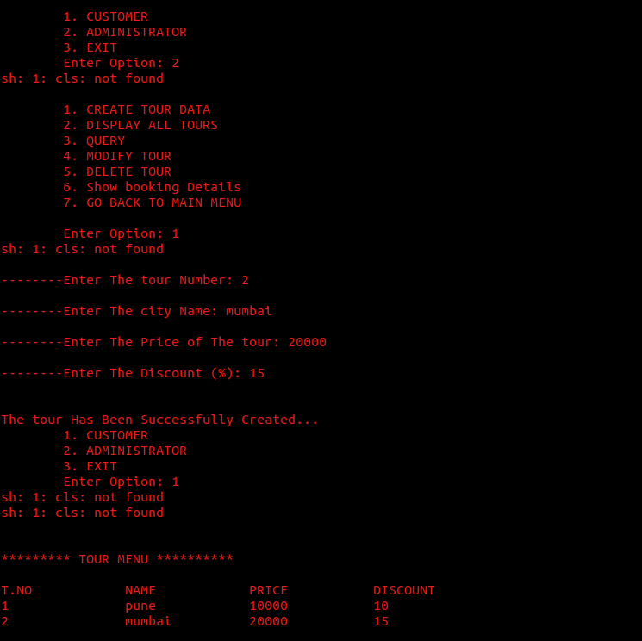

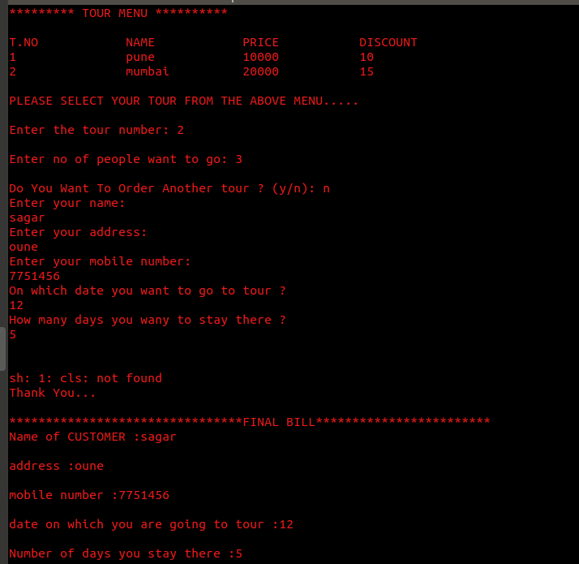

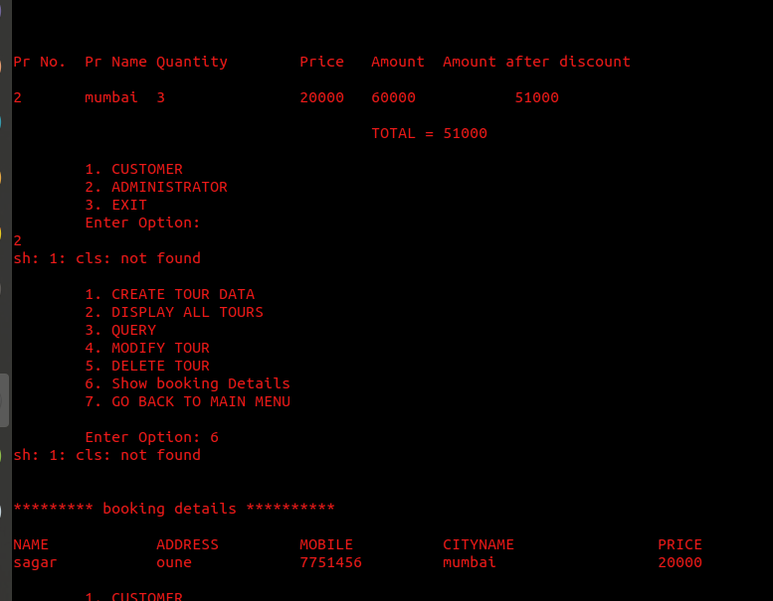

**8.Advantages:**

* Employment is increase.
* Easy to book Tour.
* Speeding up the process.
* Easy to Connectivity of customer and Administrator.
* Secure for customer.
* It’s fairly low cost.

**9.References:**

[www.google.com](http://www.google.com/)

[www.wikipedia.com](http://www.wikipedia.com/)

[www.Geeksforgeeks.com](http://www.Geeksforgeeks.com/)

[www.studytonight.com](http://www.studytonight.com/)

[www.cplusplus.com](http://www.cplusplus.com/)